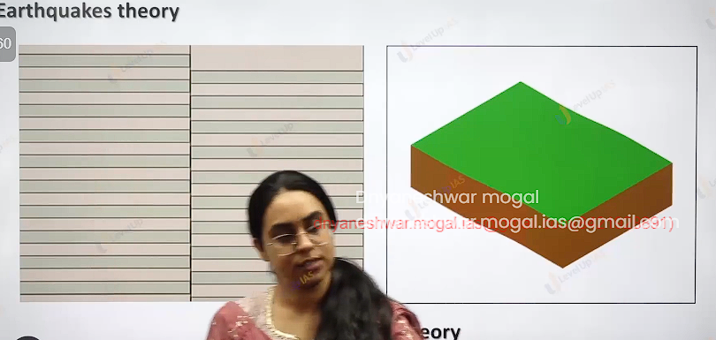

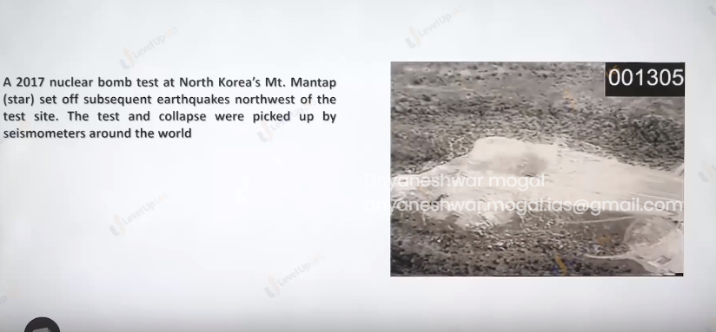

Nuclear explosions: north Korea has set of earthquake and seismic wave are recorded in world.

Elastic rebound theory.

Stress increases next to fault line.

1. It is sial floating over the sima because of sial and sima there is earthquake the occurrence of earthquake along san fancisco reason HF Reid explain the earthquake explain by elastic rebound theory. He explains the cause because of facture in the earth crust according to him rocks are like elastic which can expand when stretch and pull. It is a slow process, and rocks continue to stretch as long as the force does not exceed the elastic limit of the rock. Thee’s The force exceeds the force of elasticity the rocks break but immediately try to occupy the position back. This disturbed the equilibrium this causes the earthquake.

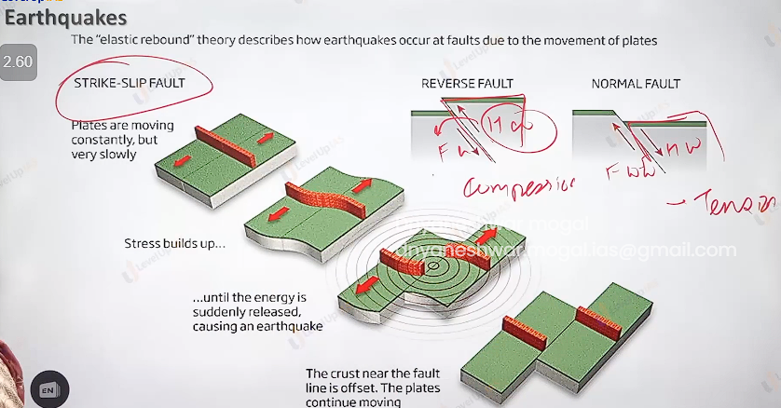

Faults and associated interaction

1. Transformed boundary has strike slip fault.
2. Tensile boundary: leads to normal fault where the foot wall goes up whereas the hanging wall slides down.
3. Normal boundary: along mid -Atlantic ridge( mid anlantic ridge can also have transform fault.
4. 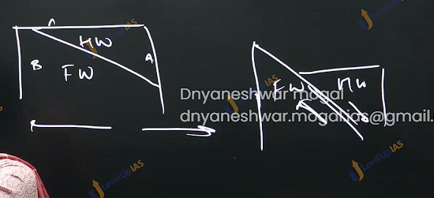

Reverse fault:

because of compression reverse fault can be formed.

Earthquake explanation by plate tectonic theory

Along the diversion boundary the lava punched the earth ocean. The diversion boundary along the continent causes thinning the rifting the continent and faulting of the continents.

Conversion boundaries:

1. o-o conversion subduction zone caused stress and fracture leading to earthquake
2. o-c conversion the ocean slab experiences the structuring of ocean floor causing the earthquake.
3. Cc conversion: strong compression causes rapid upliftment of the rock it can create reverse fault leading to strong earthquake.
4. Transformed fault can cause the fracture on the rocks leading to instability to rocks.
5. Hotspot bring out magma from the deep interior breaking the earth crust leading earthquake.

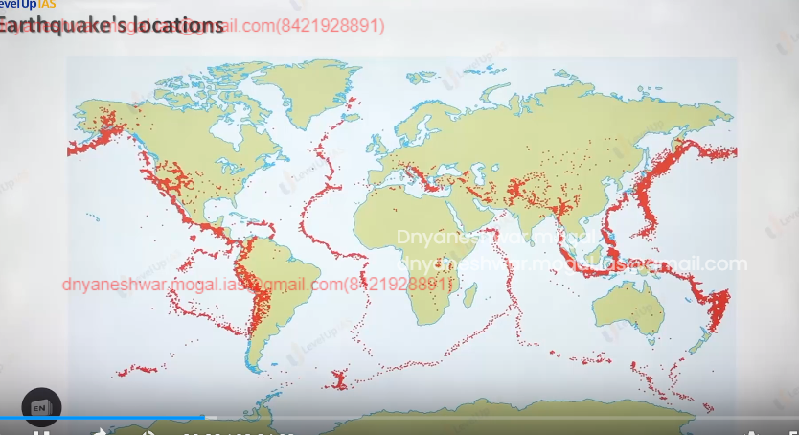

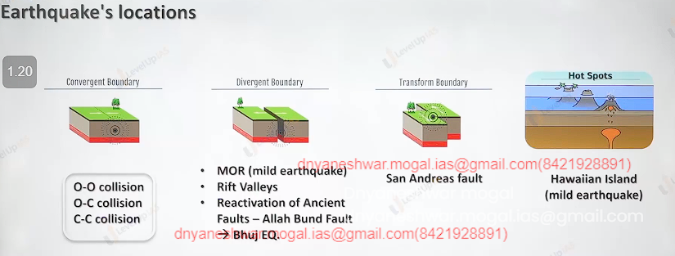

Conversions ocean-ocean conversions: the subduction zone causes stress and factures leading to earthquake.

1. Ocean-continent conversion : the ocean lab factoring of the ocean floor causing earth quake.
2. Continent – continent conversion: strong conversion cause rapid upliftment of the rock it can create the reverse fault leading to strong earthquake.
3. Transformed fault can cause factures on the rocks leading to instability in the rocks hotspot: brings out magma from the deep interior breaking the crust leading to earthquake.

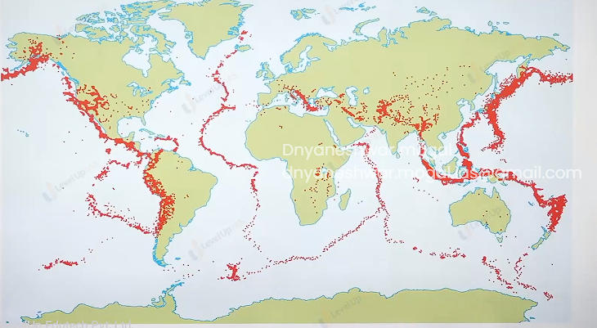

Plate tectonic and earthquake belt diagram.

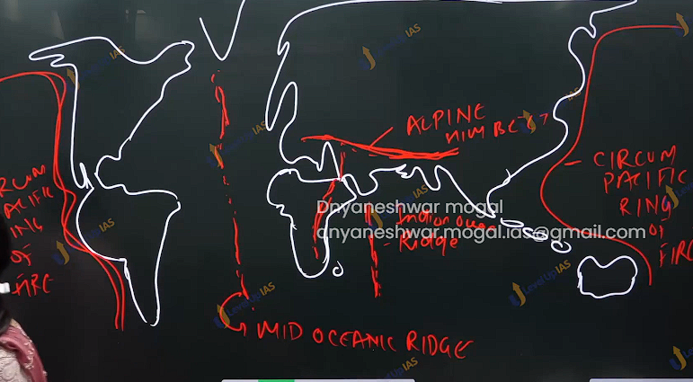

Magnitude : energy release Ritcher scale.

Intensity: effect that energy causes. Merchel scale.

Measurement of the earthquake:

1. the earthquake is measured on either the intensity scale or magnitude scale. Magnitude refears the energy release during the earthquake if it measured by Richter scale moment magnitude scale.
2. Richer scale: it was devised by Charles f. richer the magnitude on the richer scale ranges from 0-9 however its logarithms scale in reality it does not have upper limit.
3. Richter scale the scale does not give accurate reading of the earthquake of larger magnitude therefore it was companied with movement magnitude which can measure large earthquake with greater accurate
4. Mercalli scale: it measures the intensity of the earthquake
5. intensity refers effect that earthquake cause on the man made structure or the natural structure the scale ranges from 1-12 , 1 means earthquake not felt and 12 means total destruction.

India uses Medveadev-Sponhever Karnik scale. (Msk64) which is modified version of Mercalli scale.

65 % of earthquakes are seen in the cecum pacific zone. allusion reason, cumcatka pendule.20% Alphonsin Himalayan belt. 15% in the mid oceanic zone.

Distribution of earthquake in India:

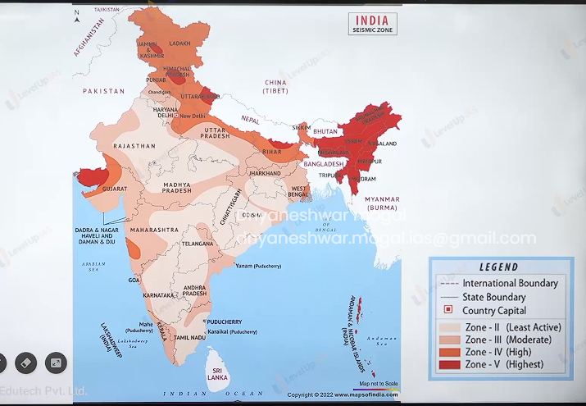

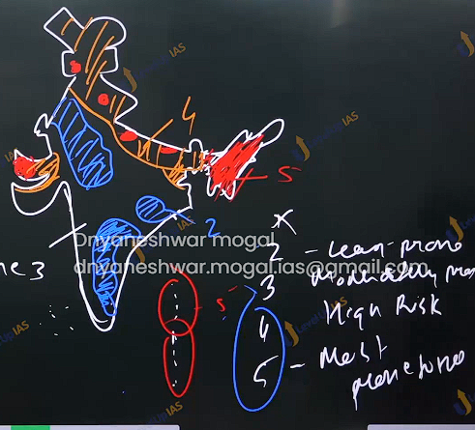

Earth quake zone in India:

1. as per NDMA 60 % of the country Is vulnerable to moderate to sever earthquake.
2. 8 % flood 16% drought 60% earthquake 7500 cyclone. Heat wave towards Sahara reason.
3. Brazed on MSK scale the seismic map of Indian which categories the country in the 4 major zone zone 5
   1. entire northeast,
   2. some part of Jammu and Kashmir .
   3. Uttarakhand and
   4. runoff kauch.
   5. Some portion of bihar and
   6. adhaman nikobar island
4. Indian plate which is subducting under the uaresion plate is causing in stability earthquake.

Zone 4 : this is high risk damage zone and covers the rest of Himalayan state, Delhi northern portion of UP and Bihar, Rajasthan and Gujrat this zone is in the vicinity of zone of 5

Zone 3 : it includes moderate risk damage zone – states like Maharashtra goa Karnataka Kerala. And costal reason AP and TamilNadu.

Zone 2 : it low damage risk zone it covers the remaining part of country and also Lakshadweep.

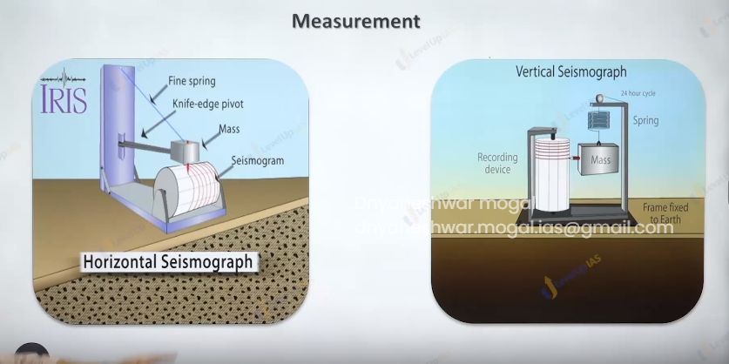

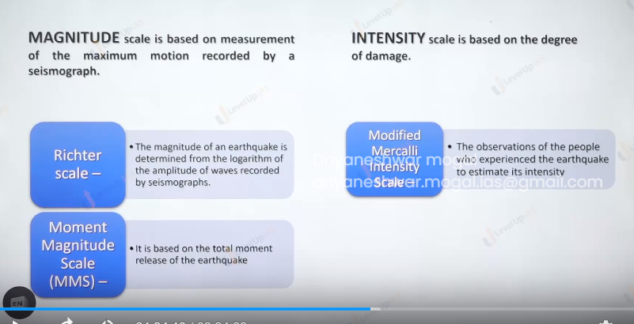

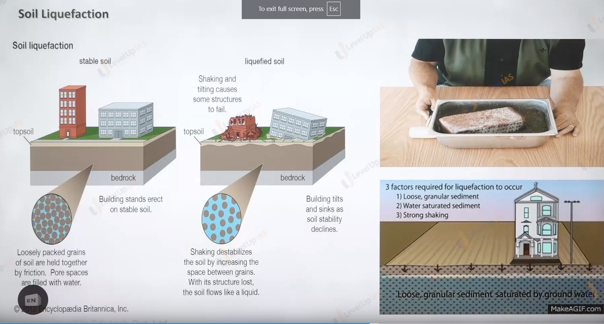

The Hazard effect of earthquake: landslide, tsunami.

1. The topographic changes of the earthquake can create fault, elevation, depression, on the surface of the earth.
2. Landslides and slope instability earthquake in hilly area which lithology which are tectonically unstable. Can cause vibrations and make soil and land unstable
3. Soil liquification when saturated soil starts behaving like water then the whole building sink in the northern belt of country like UP and Bihar where soil is generally soft and water table is high it offers suitable conditions for soil liquefaction 1934 Bihar earthquake was first slumping of entire belt of building from bettih to Purnia.
4. Flash floods earthquake can block the flow of the river, change the flow of earth causing flash flood.
5. 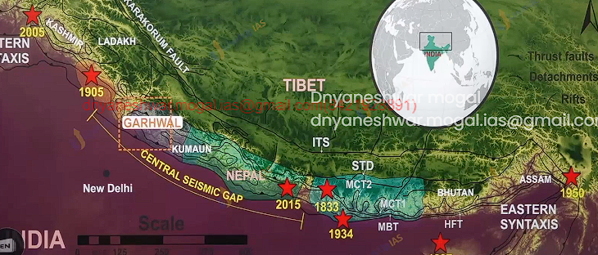
6. Lost life and property.

Earthquake Swarms: they are low magnitude earthquakes that occur in the localize over the period of time ranging from days to week months. Earthquake swarms do not flow main shock and after shock system.

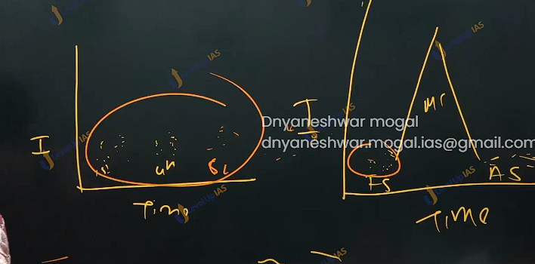

In reality earthquake flows fore shock and main shock after shock sequence, but this is not seen in earthquake swarms, but they have nearly same intensity as fore shock. It is not easy to predict the swarms will convert into earthquake.

Seismic gap: seismic gap refers to a place on active plate boundary that has not ruptured and it considered to be most likely to produce earthquake.

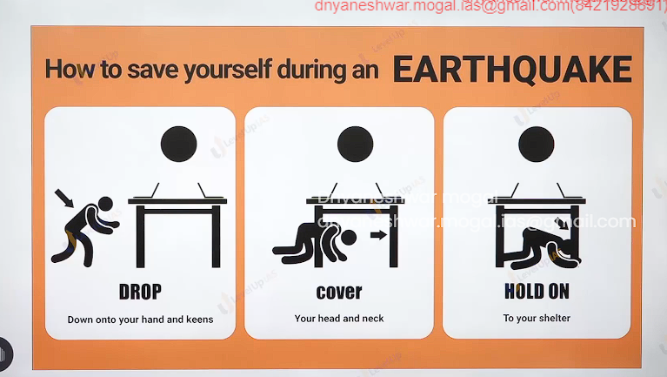

Volcano

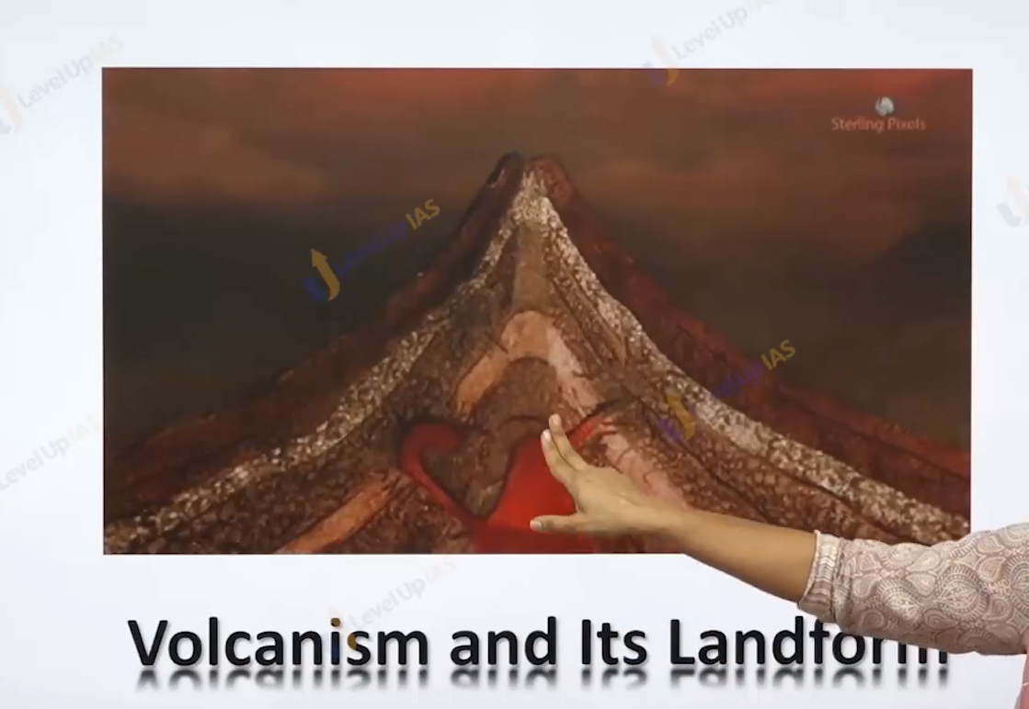

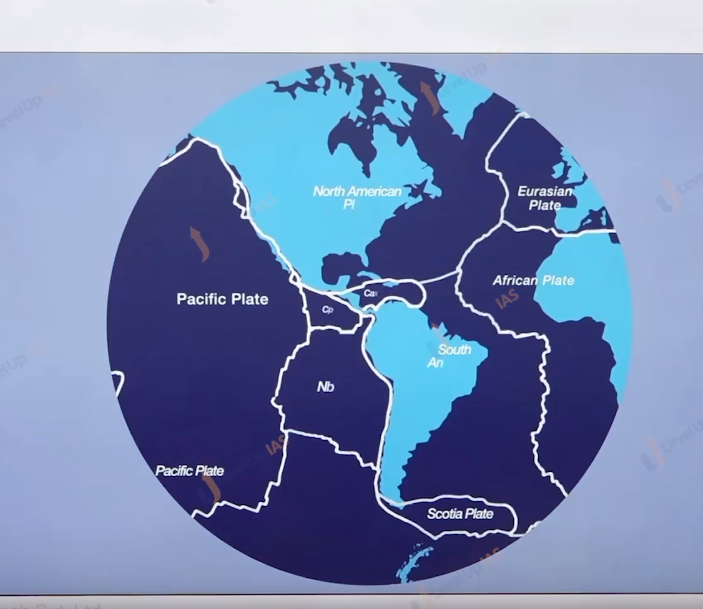

SHIELD VOLCANO

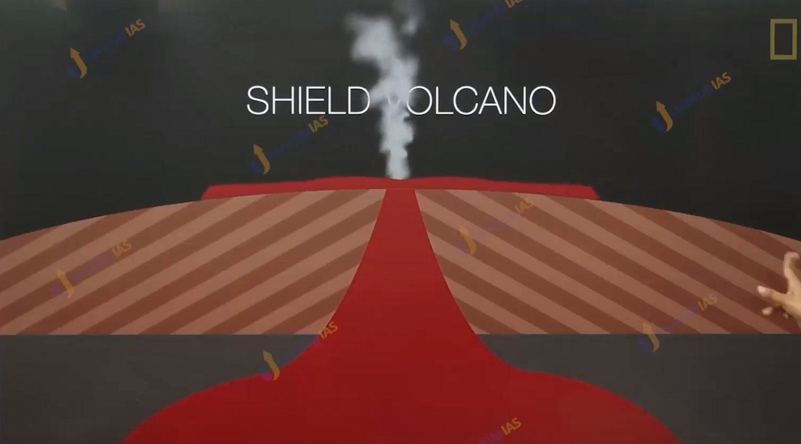

COMPOSTITE

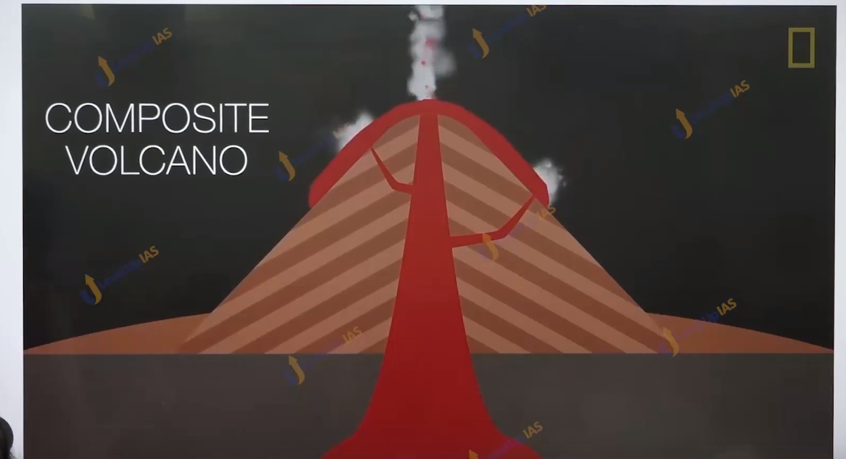

LAVA TYPE

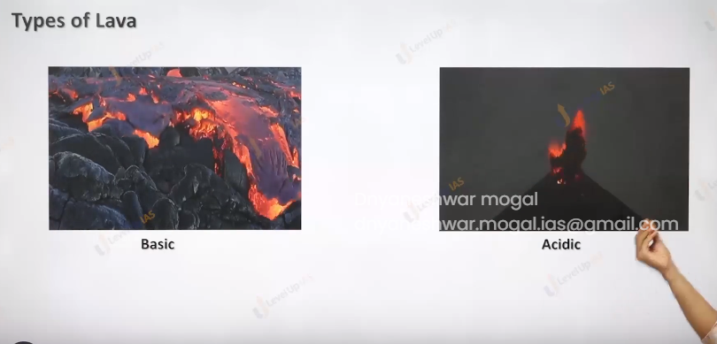

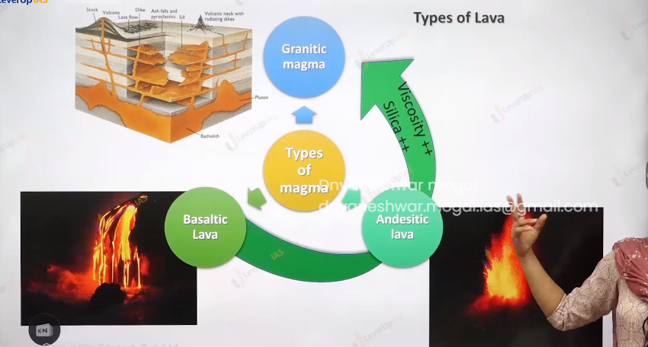

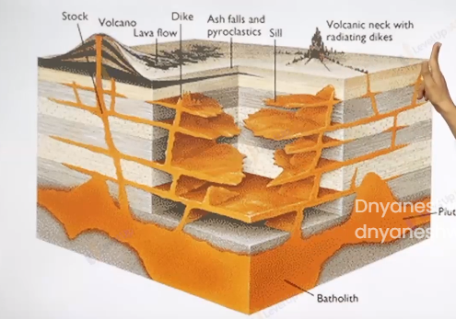

IINSTRUSIVE NAD EXTRUSIVE

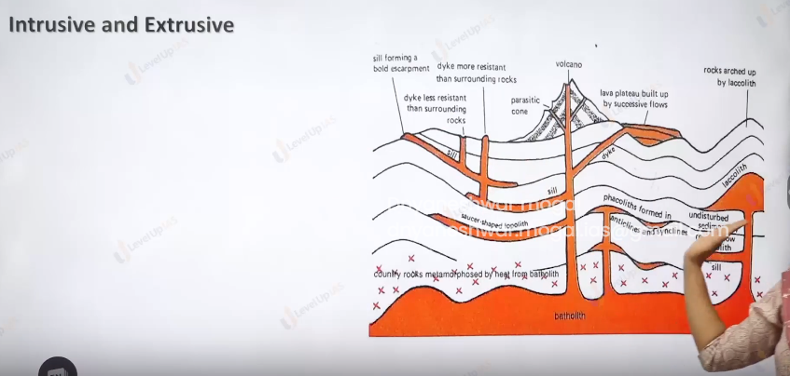

Volcanoes are a process of formation of magma, movement of magma. And solidification of magma into lava and the formation of exclusive and intrusive volcanic landforms.

The various type of landforms depends on type of magma

1. Granitic magma very high silica contain very sticky does not erupt out. And therefore, cools at deeper dept from the surface forming batholith.
2. Acidic magma has silica contain 55 to 65 % which make the magma sticky and therefore magma reaches the surface to create volcanic cones the magma erupts from the central vent. With high explosivity.
3. Basic magma: here silica contain 45 to 65 % therefore magma Is fluid and flows quietly creating basaltic plateau. The magma erupts from the long crack called fissure.

EXSTRUSIVE LANDFORM:

ex

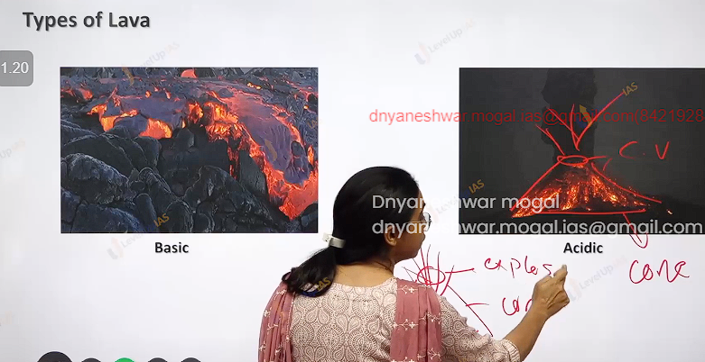

Shield volcano: they are one of largest volcano in the size. Lava is basaltic, the volcanic landform formed not very steep. It has low explosivity.

Compositive volcano: lava Is more vicious than basalt there is explosive eruption, lava, ash dust and magma erupted out in layers therefore the cone is called as compositive cone.

Basalt provinces. /plateau: very fluid lava spread over 1000 sq km, the thickness can be up to 50 meter. Deccan trap covering Maharashtra and Gujrat.

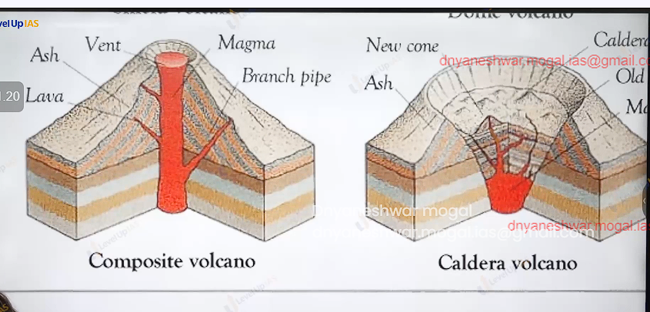

Caldera volcano: they are the most explosive volcano they are so explosive when the volcano erupts, they tends to collapse on them self rather than building any tall structure the collapse depression are called caldera. Ex in New Zealand Taupo lake.

